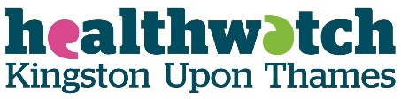
Healthwatch Kingston Board Meeting (Part A) | Date: Wednesday 31 July 2019
Report Title: Communications and Media Policy Review | Author: William Ostrom, Trustee/Director
PART A Agenda Item 10 | Appendix: No

FOR DISCUSSION AND/OR DECISION

The Board is requested to review and approve this revised policy.

Communication, Engagement & Media Policy
1. Background
Healthwatch Kingston (hereafter HWK) recognises that consistent, effective and appropriate communication (external and internal) is vital to achieving HWK’s aims and objectives. This means engaging effectively with the community, making sure people have ample opportunity to understand what HWK does, and demonstrating success and credibility as a publicly accountable organisation. This policy is a statement of intent and outlines the standards for managing communications, stakeholder and community engagement activity, contact with the media and managing social media.
This policy applies to the Board of Trustees (hereafter trustees), staff and all volunteers.
Effective communication is central to how HWK works and contributes strongly to external perception of how well we are doing and internal morale and motivation.
This Policy does not duplicate other HWK Policies, Codes, Procedures and Terms of Reference. In particular, it is important to also be cognisant of:
- Code of Conduct
- The Freedom of Information Policy and Procedure
- Decision Making Policies and Procedure
- The Business Continuity Plan
- The HWK Volunteering Policy
- The HWK Data Protection Procedures

2. Scope
This policy aims to help HWK communicate more effectively by delivering a better understanding of what it offers to the public and by arranging its work as efficiently as possible, particularly to:
- Establish HWK as credible, trustworthy, and adaptable
- Demonstrate HWK is an effective consumer champion
- Build awareness of HWK amongst local people
- Develop fresh and relevant ways of engaging and involving people and organisations
- Engage in active partnerships with organisations that assist the aims of HWK
- Increase the number of people actively participating in HWK activities
- Broaden the range of interests represented by participants in HWK activities
- Support and facilitate grassroots led community development
- Signpost local people to information about their health and social care services effectively

3. Standards
In order to ensure that communications on behalf of HWK are effective and of a high standard, all communications must:
- Adhere to a corporate style (e.g. using Healthwatch branding)
- Represent the voice of HWK as a whole (e.g. what HWK says and how it is said)
- Embody the Nolan Principles as set out in HWK’s Code of Conduct
Furthermore, any planned communication must be:
- Open - all information should be communicated in an open and honest fashion. In the light of the Freedom of Information Act, all information should be accessible by any member of the public except where it would contravene data protection.
- Relevant – information should be clearly relevant to the audience to which it is delivered. The needs of the audience should be put first in all communications activity and information should be tailored to ensure that it is relevant to different audiences. If the recipient is expected to act on the information they have received this should be made clear to them.
- Simple - straightforward language should be used in all written and verbal communication. The use of jargon and "management speak" should be avoided. Messages should be carefully thought out and constructed so that the point is clear.
- Factual – at no time should HWK ever speculate.
- Actions - any actions expected of the recipient should also be clear. Messages should not be needlessly long or complicated and all communication should be consistently of a high quality.
- Clear - all communication should be clear in its aims. Message senders need to tell their audience in direct terms the status of the information they are communicating.
- Planned - information should be prioritised and planned so as to avoid overload, duplication of messages or long periods of non-communication. Communication and engagement with the public should be at the heart of all planning within HWK.
- Two-way - all communication should ensure that there are as many opportunities for listening and receiving questions as there are for sending messages out. In this way communication will be positively encouraged and the public will feel that they can influence the work and progress of HWK.
4. Audience
HWK aims to reach out to all members of the community and in so doing ensure that all those who have an interest in the work of HWK are kept informed on a regular basis and invited to participate. HWK’s target audience are (in no particular order):
- General public
- Community groups
- People who use health and social care services
- People who are rarely heard or represented
- Voluntary and community sector organisations
- Health and social care agencies (e.g. Clinical Commissioning Group, Local
- Authority, NHS Trusts)
- Local councillors and MPs
- Media
Audience priorities will change depending on the nature of the work being undertaken by HWK. For instance raising the profile of HWK will involve the whole community whereas targeting a specific service area will focus on users of that service and their carers, family and friends as well as staff. Either way, the key to successful communications is an active stakeholder and community engagement process, which could be as simple as picking up the telephone, or meeting for a coffee or something more complex like organising a series of community engagement events.
5. Communication Methods
Communication and community engagement will be achieved through a variety and changing mix of methods and media, within HWK resources, commensurate with the information or message concerned and the intended audience or recipient, for example:
- In person - through outreach and community engagement activities, at meetings and events which are best suited for ensuring a clear understanding.
- Existing Channels - local voluntary and community groups, networks, newsletters, GP surgeries, libraries etc. The format used should be appropriate to the setting.
- Printed Matter - posters, leaflets, flyers, reports, banners, advertising boards, and invitation letters.
- Press, radio and other media - the Chair of the Board of Trustees with staff support will have overall responsibility to make use of opportunities to communicate widely and effectively and to respond to issues through editorials, letters and articles.
- Information and Communication Technology - the Internet is the most cost effective form of communication and can communicate all HWK information, activities and policies. The staff team will provide and maintain a HWK website with facilities for information exchange. Social media such as Facebook, Twitter and YouTube will be used to communicate to wider audiences. HWK, however, recognises that a large number of people are digitally excluded and every effort must be made to engage with them using printed medium and face-to-face interactions
- Email - used whenever possible, email is a quick and effective means of disseminating and requesting information and responses and asking and answering questions
- E-Bulletin – published monthly to disseminate relevant information on a regular basis and inform and signpost recipients to other sources.
6. Stakeholder and Community Engagement
HWK’s aims to engage with a range of individuals and organisations and who are interested in participating in the work of HWK. This could include individuals and organisations (not necessarily from the health and social care sector) or politicians and key opinion leaders. For HWK communicating and engaging with stakeholders and the community is an essential part of everyday business. Effective stakeholder and community engagement processes, however, take time and planning and must extend beyond the core group of organisations and individuals that stand out as key to HWK. Failure to do so will mean that HWK will not reach out as widely as possible.
In order to have a positive influence on health and social care services HWK will endeavour to use a wide variety of communication tools to increase the number of people aware of HWK as well as supporting meaningful participation in the work of HWK. This will include:
- Working in collaboration with others, statutory and voluntary sector partners, to make the most of HWK’s capacity to communicate and raise awareness across the whole population
- Engaging creatively and meaningfully with the public from every part of the community, empowering them to speak up and champion the voice of those who often struggle to be heard
- Listening to what the public say matters to them, so HWK can communicate these messages and speak up on behalf of the community
- Ensuring the public are informed of the standard of care and information they have a legal right to receive and are signposted to appropriate services to meet their needs
- Supporting wider participation and better communication with the whole community, particularly those groups/or individuals that are underrepresented
Good communication is at the heart of effective stakeholder and communication engagement processes and is key to strengthening links with individuals and the community. Figure 1 shows HWK’s tiered approach to communication, each tier corresponding to a narrower group of people, each having different communication needs. For instance, most of the day-to-day business of HWK is related to individual or community engagement activity, or providing advice and information, supporting volunteers and answering queries from the public. Consequently it is vital all communication activity needs to be inclusive, varied, timely, accurate, accessible, and on going.
HWK is a relatively small player in a complex and extensive health and social care system, there are many new organisations involved in health and social care services with new responsibilities to put consumers at the heart of their work. HWK is committed to working closely with key stakeholders from the statutory and voluntary sector, particularly, working with relevant community engagement teams from across the sector. HWK does not need to replicate work if it is already being successfully delivered by other organisations, nor does it want to duplicate expertise others already have. The focus of HWK is to use the information it finds and receives effectively and thoughtfully.
HWK’s will use its communication resources to gather the broadest possible views and to access those voices that struggle most to be heard. HWK will target specific groups using a variety of communication approaches as advised by people from the group. In order to seek a diverse range of views, particularly those who find it hard to be heard, HWK will consider setting up focus groups, workshops and meetings to improve and to help broaden communication across communities.
HWK’s stakeholder and community engagement work is determined using a bottom up and top down approach, i.e. from the bottom up as a result of the issues, trends and themes that present themselves as a result of the voice of the public, and from the top down as a result of local, regional and national priorities, or topical issues in the media, for example. This work could include working with people on an individual or small group basis to undertake Enter & View visits, so that they can see and hear for themselves how services are provided. Alternatively HWK can work with individuals to gather intelligence and collect evidence about specific service areas to support the development of new communication approaches to broaden involvement.

Figure 1 Communication Tier
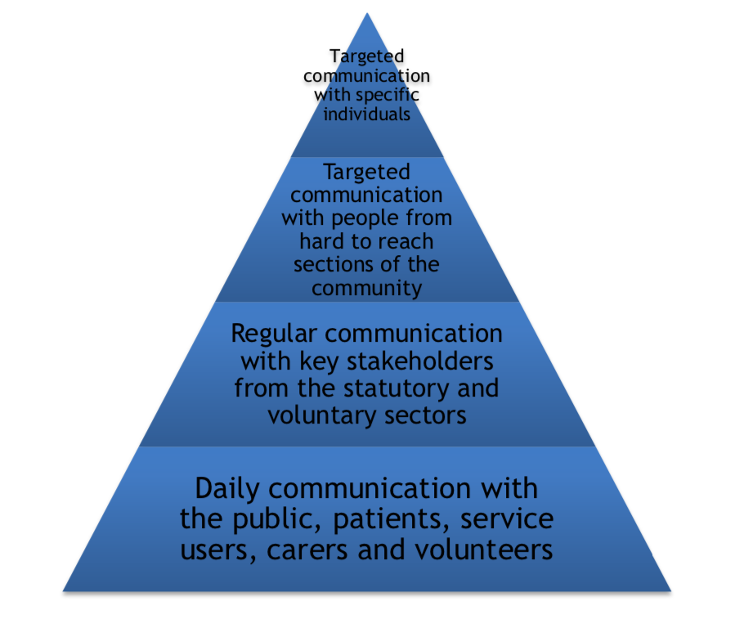
7. Media guidelines and practises
As the consumer champion for health and social care services, HWK may be in the media spotlight. To achieve fair and accurate coverage of HWK and its activities, al trustees, staff and volunteers need to understand the approach when promoting HWK in the public eye. If handled correctly, media exposure can provide the means to convey messages to a wide audience and to promote HWK expertise and reputation.
It must be recognised the media is primarily in the business of news gathering and production. This process frequently means stories tend to be oversimplified and the aspects with greater impact brought to the foreground. HWK does not sensationalise its messages so great care must be taken to ensure our commentary emerges as independently and accurately as possible.
For this reason HWK needs to ensure that the content of all that is said externally (and thus commit to the record) is always consistent with approved messaging and in line with the desired media positioning of HWK. Consequently only a designated media lead should talk to journalists. For HWK this is the Chair of the Board of Trustees. If a journalist contacts anyone else directly it is important not to engage in conversation except for asking what their query is, what their deadline is and that you will ask the relevant person to get back to them. Dependent on the recipient of the call the Chair should be informed as soon as possible or if not available the Manager of HWK should be contacted. The Chair should approve all news releases, articles and letters to the media.
8. Social media guidelines and practises
HWK will make appropriate use of social media including Twitter, Facebook and YouTube to provide information to the community about HWK’s role and activities. As with any other online activity there are potential risks such as:
- Damage to the reputation of HWK
- Virus or other malware (malicious software)
- Disclosure of confidential information
- Breach of safeguarding
- Abuse or discrimination
- Over-attending to unrepresentative or marginal forums and channels
In light of these risks, HWK will monitor and regulate the use of social media sites and ensure action will be taken to address suspicious activity. Trustees, staff and volunteers must engage social media sensibly and responsibly; everything is on the record. In particular, they must not:
- Say anything that may harm the goodwill or reputation of HWK or any disparaging information about HWK
- Provide any disparaging, discriminatory or harassing information concerning any trustee, staff member or volunteer, partner organisation or other person/group associated with HWK
- Divulge any confidential information or intellectual property of HWK
- Share any private information relating to a trustee, staff member or volunteer or partner organisation of HWK.
- Accept or rely on any visual material without complete verification (and subject to data protection). The frequent use of apps to misrepresent, alter and distort original imagery has reached a high degree of adoption.
In compliance with good practice and transparency, trustees, staff members or volunteers endorsing HWK’s services must disclose their involvement or relationship with HWK and must ensure that endorsements do not contain representations that are deceptive or cannot be substantiated. If a trustee, staff member or volunteer is speaking about job- related content or about HWK they must either clearly identify themselves as a HWK trustee, staff member or volunteer, or speak in the first person and use a disclaimer to make it clear that the views expressed are solely theirs. This Policy applies regardless of where or when a trustee, staff member or volunteer post or communicate information online. It applies to posting and online activity at work, home or other location and while on duty and off duty. HWK reserves the right to monitor and access any information or data that is created or stored using HWK’s technology, equipment or electronic systems, including without limitation, e-mails, internet usage, hard drives and other stored, transmitted or received information.
In order to ensure that HWK avoids the common pitfalls associated with social media it will refer to the checklist included as Appendix A.

9. Promoting awareness of service change in the media
HWK can use the media to ensure that the community are both properly informed about issues of service change and consulted by decision makers. It is important to demonstrate to the media that HWK is engaging with the public face-to-face and that it understands the real issues. This could involve co-hosting an event with a local media outlet, such as a ‘Question Time’ style debate. This type of partnership work helps generate awareness and demonstrates to the media the value added by HWK.
10.Consent and confidentiality
HWK has a duty to protect confidentiality in accordance with its Confidentiality and Data Protection Policy. HWK will not share information that will lead to the identification of an individual without their informed consent. All approaches for interviews, statements or stories must have the consent of the individual as provided, in the case of HWK, by the signing of a media consent form (see Appendix B).
11. References
The following publication was used to produce this document:
• Healthwatch England: Service change – communications support, 2015
12. Document Control
Title of Document: Communications, Engagement & Media Policy
Board Approval Date: tbc | Review Date: July 2019

Appendix A
Social Media Checklist
The benefits of engaging with a vibrant, discursive online community around local health and social care issues are compelling, and the established social media platforms twitter, Facebook, blogs and YouTube are an excellent and effective way to achieve this. They are not without risk however and should only be engaged with having weighed the potential downsides. In order to proceed the following checklist items must be completed:
1. Is there a clear purpose for being on each platform?
Unless each platform (i.e. Twitter, Facebook, YouTube and blogs) can deliver a useful outcome that everyone understands, it is best to avoid that platform. For example:
  - Facebook to promote workshops, focus groups, events and other engagement activities
  - twitter to engage with young people over their experience of health and social care
  - YouTube to broadcast personal experiences of people using health and social care services
2. Is there a clear idea of who the audience on each platform is and how to engage with them?
Everything from the type of content to the tone of voice employed should be considered against who the Healthwatch audience is. Such as conveying an approachable, practical and dynamic public persona that acts on behalf of local people
3. Is there a member of staff who is empowered to speak on behalf of the organisation and is able and willing to devote time to social media?
The two most common reasons an organisation fails to make an impact on social media is that the task is given to someone who has neither the time or experience to do the job well or a junior member of staff is allocated the role but does not have the judgement necessary to be the public voice of an organisation. These days the public (and press) are more likely to encounter Healthwatch through their Facebook or twitter page than they are in real life and thus the voice of Healthwatch social media should be considered to be synonymous with its public persona.
4. Beyond reputation management and public profile, has consideration been given to how social media can help people to ‘get the best out of local health and social care’?
Healthwatch is all about local voices being able to influence the design and delivery of health and social care services. Social media provides a valuable outlet and potential source for these voices. Healthwatch must have a plan for how to encourage those voices, listen to them and amplify their influence. Conversely, if people are tempted to use Healthwatch public platforms to disclose their personal details or information about complaints that should not be in the public domain, the conversation must be moved onto email as soon as possible. Even in this situation, it must be remembered those emails may be made public by the recipient; everything is on the record.
5. Are all passwords and log-ins centrally collected?
Many organisations leave a stream of abandoned social media presences behind them as staff leave. The result could be that the Healthwatch reputation is not under control. Everyone in the organisation should be clear that no social media presence can be created without approval at the top of the organisation and without all the passwords and log in information being collected centrally in a maintained spreadsheet.
6. Does the designated social media spokesperson understand the etiquette of twitter and/or Facebook?
Using @twittername will address a remark to a person directly if it is at the start of a tweet or will include them if it occurs later in the tweet while #somethingexciting will include a Healthwatch tweet in a general conversation about a hot topic. Twitter users respond well to short, timely remarks about topical issues whereas Facebook content tends to be visible a lot longer and can focus more on images, events and general discussions. Remember that while it is technically possible to delete a tweet, there is always a record: so if in doubt, don’t tweet it.
7. Is commenting in YouTube turned off?
Comments in YouTube can be harsh and deliberately provocative. Unless Healthwatch is staffed to monitor and respond to any commenting on its YouTube videos, it is almost always best to turn off commenting as a feature when the video is uploaded.

Appendix B
Media Permission Form Personal Stories and Photography
Thank you for agreeing to help Healthwatch Kingston and allowing us to use your story and/or photograph to publicise our work.
I hereby give permission for Healthwatch Kingston to use my story and/or photograph to help promote its work in the following ways (*please delete as applicable):
*Annual Report / Newsletters / Publicity Materials which may include Posters, Leaflets and Advertisements / on Healthwatch Kingston’s Website and YouTube Channel.
I also agree to the story and/or photograph being released to (*delete as applicable):-
*Newspapers / Television / Radio / External Websites
Please tick one of the following:
- □ I would like to remain anonymous and for false names to be used by the media to identify people in the story.
- □ I am happy for my / our real names to be used in this story.
- □ I would be happy to be approached by the Healthwatch Kingston to
be invited to take part in newspaper, radio and television interviews.
If you change your mind and would like us to stop using the story for any reason, please contact us on 020 8974 6629.
Thank you again for your help.
Name: ______________________________________________________ Contact No: _________________________________________________ Signature: _______________________________Date:____________

