cid:image001.png@01D3EDEC.8C5546A0

|  |  |
| --- | --- |
| **Healthwatch Kingston Board Meeting (Part A)** | **Date:** Wednesday 31st July 2019 |
| **Report Title:** Projects and Outreach Officer | **Autho**r: Scott Bacon (SBA) Projects and Outreach Coordinator (Learning Disabilities) |
| **PART A Agenda Item 12** | **Appendix:** No |

|  |
| --- |
| **FOR DISCUSSION AND/OR DECISION** |
| The purpose of this report is to update the HWK Board on recent and planned Projects and Outreach. |

**All Age Learning Disability Partnership Board**

We held our first community event at Kingston Hospital on 17th July. The feedback will be brought together by our new volunteers starting in August. Initial feedback was very positive.

We explained to the community about the Partnership Board, the project work on Health and Wellbeing and Communication. There was also the opportunity to advertise the Learning Disability Task Group and the hospital promoted their acute care work. As well as fun sessions on Makaton and Chair Based Exercise.

The event was attended by 49 people. A mix of professionals and the public. 24 are people with a learning disability or their carers. 49%.

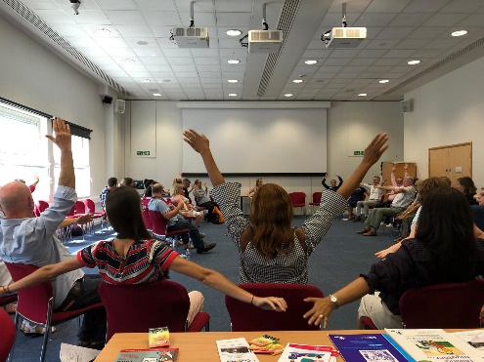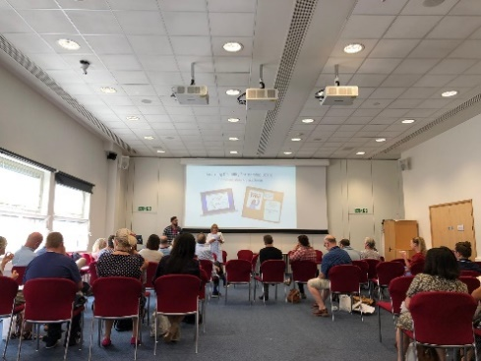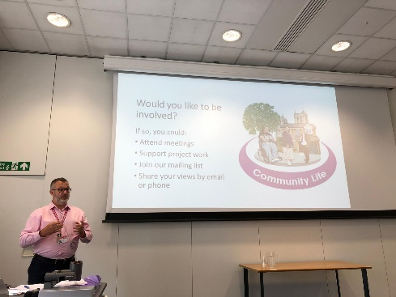

**Kingston Hospital**

The 15 Step Challenge with students from SEN schools will take place on 25th September. Students from Dysart, Bedelsford and Orchard Hill will be reviewing the Royal Eye Unit and Oral Health Unit at Kingston Hospital. Representatives from Orchard Hill, Dysart and Bedelsford will support this.

Through our attendance at the Kingston Hospitals Acute Care Learning Disability Collaborative we will be supporting their review of the Hospital Passport.

**Learning Disability Task Group**

The second date for the task group has been confirmed for Tuesday 6th August 2019.

The first meeting was very well received. We spoke about what a task group can do, how it will run as well as any issues the group would like us to address.

There was some confusion about being a chairperson for the meeting. The group thought Healthwatch did everything and they contributed. So the meetings will run with myself taking lead of them while we recruit for a chair and vice-chair for all groups.

We spoke about issues with some pharmacies not releasing medication for hospital prescriptions and some pharmacies releasing them. We spoke about the issues with getting appointments at a GP. One of the group is often told to wait two weeks as no appointments before that, they then get a telephone appointment but often ends up coming in as an emergency as there is nothing in between emergency or two-week wait.

We want to create an easy read information sheet about the Learning Disability Protocol when entering the hospital. So people with Learning Disabilities and their carers know their rights.

We will create a list of questions for the pharmacy group so we can see their policies and find out why people are being treated differently in different pharmacies.

We will be writing a letter to the CCG on the statistics for annual health checks being completed with people who have learning disabilities. Speaking with the Learning Disability Community Nurse (Maita Jenns) there is a reluctance from GPs to give an annual health check. This contradicts some of the GPs that she works with in Richmond. Who book out a whole day for 4 or 5 Annual Health Checks as well as conducting Health Checks in the car park when someone couldn’t get themselves any further because of their anxiety. Richmond has a 70% uptake on annual health checks for people with learning disabilities, Kingston is currently at 38%. (statistics from Maita).

**A new staff member and volunteers**

We have appointed to the Learning Disabilities Support Officer role. This post will begin in August.

We also have three new volunteers coming in once a week to help out in our office.

**YOL!**

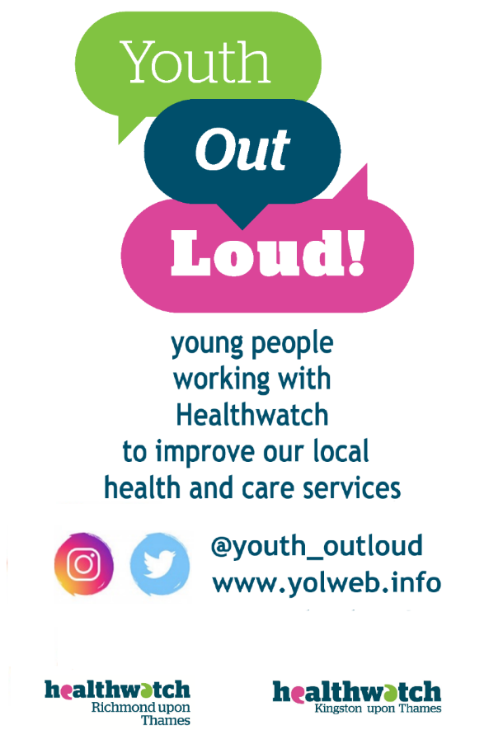

Youth out Loud! have met with Off the Record in Richmond as well as other mental health professionals to learn more about self-harm and supporting someone who is self-harming before making their next video.

As agreed before the videos will use the ‘WhatsApp/message’ template. YOL! want the conversation in the video to be worked around offering advice/support for someone who is self-harming.

We have been hindered by exams and now summer holidays. Meaning many of the students are busy or need to rest. This is something we will learn from for next year and ensure we have planned ahead and have less pressure (not trying to make a video) this time next year.

They have also met with Sarah Freeman from Wolverton (Sexual Health Clinic) about her work and discussed what can be done together. They have concerns that people are put off attending. So maybe make a video (with go pro/phones – not professionally) about what it’s like to visit as a young man or young woman.

**Mental Health Task Group**

Sharon Brookes, Service Manager CAMHS, came and spoke at the previous Mental Health Task Group. As the group is beginning their work on transition from CAMHS to adult services we asked Sharon for her opinion on how transition works and what the issues are.

She was very open about what she believes these issues to be.

We have found out that Your Healthcare is doing a similar piece of research on transition. There work focuses on neuro-diverse young adults in transition.

We have held our stakeholder meeting on 25th June to see what the scope of our work could be. We offered four choices of times/dates and picked the most popular. Your Healthcare presented on their work. No final decisions on our work have been made, other than it will not replicate the work of your healthcare.

One of the comments from the meeting was that Wandsworth have a transitions officer. I have found a contact for Wandsworth Transitions Team, managed by Eric Richardson. We will be speaking to him about how their set up (how they decided to set up, any feedback they have about their transition) can support our work.

We have a contact at Kingston College (Jamila Jama) who has offered us access to students, who she believes will be willing participants.

We continue to work closely with Your Healthcare on this. They spoke at the Learning Disability Partnership Board Community Event (impromptu, but agreed) and believe to have recruited two families for their research from their brief speech. They have also offered us access to their protocols should we need them.

**Volunteer Fair/Volunteer Kingston**

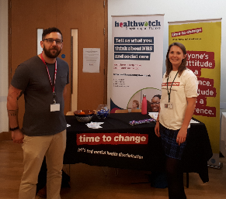We had a stand at Volunteering Kingston’s volunteering event at the Quaker Centre.

We held two stands next to each other, Healthwatch and Time to Change. It was noted that our volunteering opportunities are not on their website. This is on my list to be actioned.

**Time To Change.**

We attended the Kingston Business Expo on behalf of Time to Change trying to engage with local businesses and increase their understanding of becoming a champion and signing the employer pledge.

We also attended the Blue Light Champion Event at St Georges (Kingston University Campus). Speaking to training staff as well as practicing staff about becoming champions. Many of the staff were already involved in supporting/raising awareness of Mental health in their workplace as Blue Light Champions are mental health champions for the emergency services.

**First Aid**

I attended a one-day course on emergency first aid (physical) and the certificate is on the wall in the office and expires 10.06.2022.

**Mental Health First Aid Training**

I attended the adult mental health first aid training. It was very similar to youth mental health first aid and I fed this back when completing my feedback. It is not a massive issue but for people like us supporting adults as well as young people my opinion is it doesn’t need two sets of training.

**Disability Confident**

I attended disability confident training to support working with staff and volunteers with disabilities. I learnt about reasonable adjustments. This training is not linked to the disability confident scheme but the benefits of attending will help us with our application to be a Disability Confident Employer.