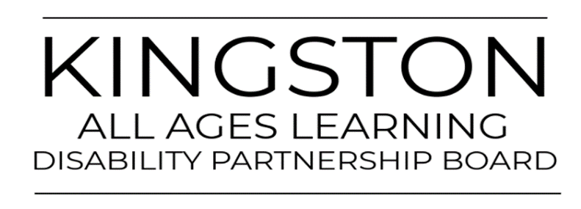

All Age Learning Disability Partnership Board Health and Wellbeing - Community Event

 | On Friday 2nd September 2022
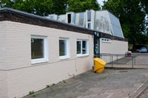 | At Searchlight Community Centre, Kingston Road, New Malden KT3 3RX  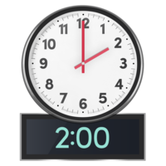  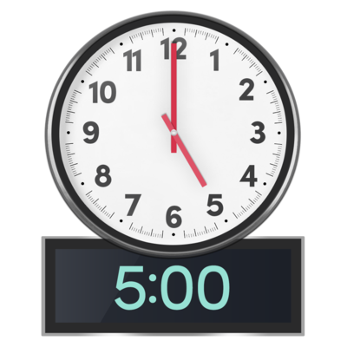  to
 | There will be different stalls from services for people with Learning Disabilities
 | There will be food and drink
 | There will be some sports to try out.
 | There will be drumming to listen to and a sing and sign session, and much more!
If you would like to come, please email: info@healthwatchkingston.org.uk for more details.
Do you have any access needs, allergies, or food needs?
Transport: Will you need parking?

