Survey
Care Home and Other Residential Care: Residents
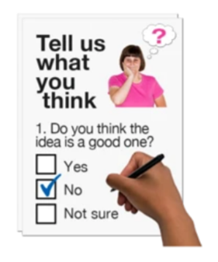 | This is a survey for a report for Healthwatch Kingston.  We will not give out your name or postcode. We will only use your information for this survey. This can only be seen with a password.
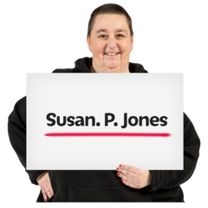 | Please tell us your name:
 | Please tell us your age:
Healthwatch are the local champion for health and social care services in Kingston.

We work with, but not for, the NHS.

We also work with Kingston Council.

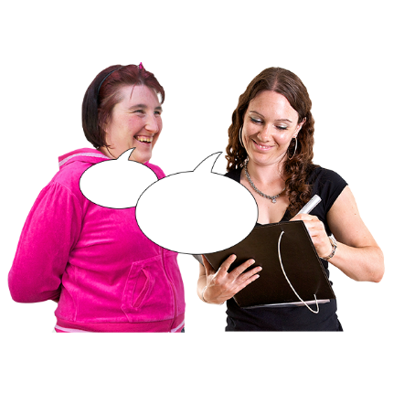 | Did you need any help to fill out this survey?  ☐ Yes  ☐ No

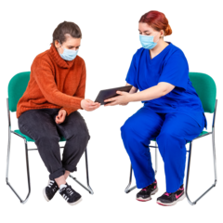 | If you did have help, who helped you?  ☐ A family member  ☐ A friend  ☐ A carer  ☐ Someone else
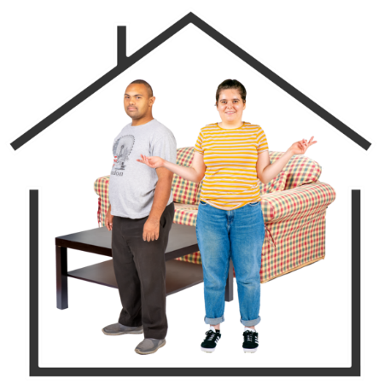 | What type of place do you live in?  ☐ A care home  ☐ A supported living home  ☐ Extra care housing  ☐ Other type of home
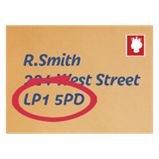 | Can you please tell us your postcode? It will not be in our report:

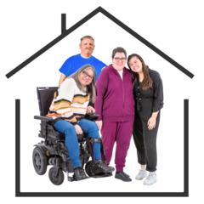 | How would you describe your experience of living in your home before the COVID-19 pandemic? This is before March 2020:  ☐ Good  ☐ Bad  ☐ Neither good or Bad
 | If you would like to tell us more, please do so. If not, please go to the next question:
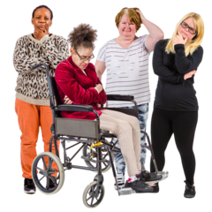 | How would you describe the experience of living in your home during the Covid-19 pandemic?  ☐ Good  ☐ Bad  ☐ Neither good or bad
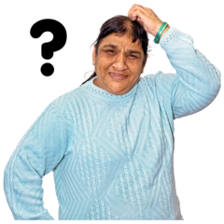 | If you would like to tell us more, please do so. If not, please go to the next question:

Were you able to take part in any activities that were happening at your home during the Covid-19 pandemic?
☐ Yes

☐ No

 | If you would like to tell us more, please do so. If not, please go to the next question:
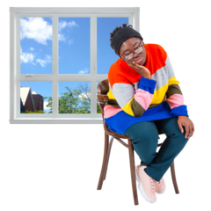 | Which three activities have you missed doing since the beginning of the pandemic? And why do you miss doing them?  1-  2-  3-
If you needed to see a doctor during the pandemic, how did they treat you?
☐ Phone

☐ Video Call

☐ In person

☐ I did not need a doctor

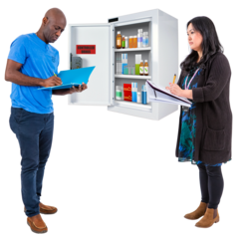 | Were you able to get medical care and/or medication when you needed it?  ☐ Yes  ☐ No  ☐ I did not medical care and/or medication
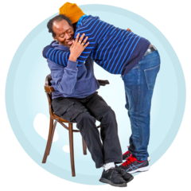 | Were you offered any emotional or mental health support during the pandemic?  ☐ Yes  ☐ No  ☐ I did not need emotional or mental health support
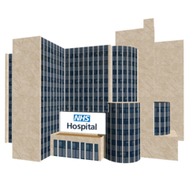 | Did you have to go into hospital during the pandemic?  ☐ Yes  ☐ No  ☐ I did not need to go into hospital

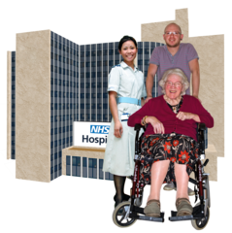 | If you went into hospital during the pandemic, please tell us about what happened when you came out of hospital? (For example, did they send you back to where you lived before, or somewhere else?)
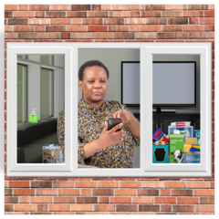 | Did you have to self-isolate?  ☐ Yes, in my own room  ☐ Yes, in a room with others  ☐ I did not need to self-isolate
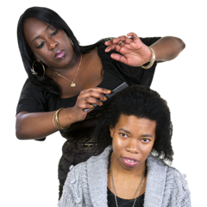  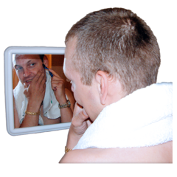 | Were you offered any personal care, such as hair or nails trimmed, or shaving or beard trimming?  ☐ Yes  ☐ No  ☐ I did not need personal care facilities
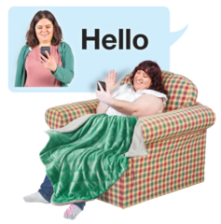 | Have you had the chance to speak to family or to your friends since the pandemic?  ☐ Yes  ☐ No

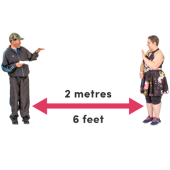  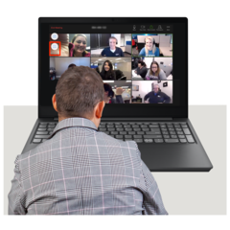  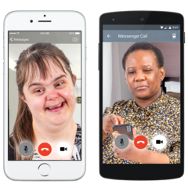 | How have you spoken to them?  ☐ Phone  ☐ Video call  ☐ In Person
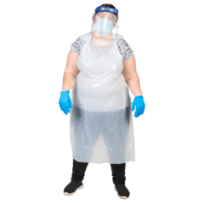 | If you were visited by friends or family members during the pandemic, did anyone give them Personal Protective Equipment (PPE) such as masks, and aprons?  ☐ Yes  ☐ No  ☐ I was not visited
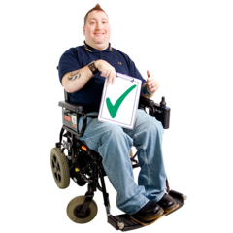 | If there was only one thing that could make your home life better, what would that be?
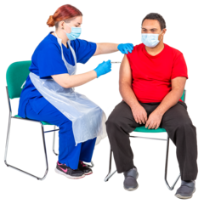 | Have you had a Covid-19 vaccine?  ☐ Yes  ☐ No  ☐ I do not want the Covid-19 Vaccine

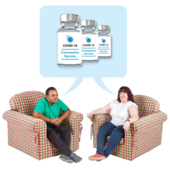 | If you have had a Covid-19 vaccine, please tell what it was like for you?
If you are worried about the care you are getting, would you feel comfortable talking to someone about it?

☐ Yes
☐ No

If you said yes, please tell us who you would share your worries with?

If you said no, can you please tell us why?

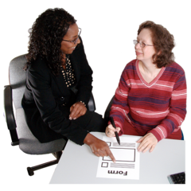 | If you would like to tell Healthwatch Kingston anything else about your pandemic or lockdown experience please do? If not please move on to the next question:

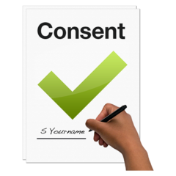 | Your answers to these questions will make your services better.  When you sign this form, it means you are happy for us to share this information with Healthwatch Kingston.
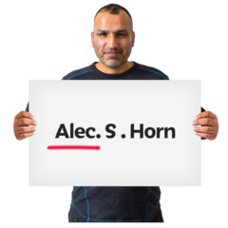 | Your Name:
 | Your Email:

A BIG thank you from all of us at Healthwatch Kingston.
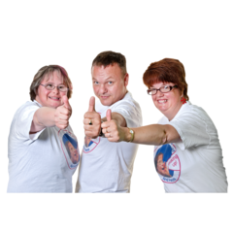
We look forward to seeing you soon.

If you would like to send us your questionnaire by post, please stick the Free Post label below on the envelope.

