Our work with people with learning disabilities
Meaningful Engagement of people with learning disabilities:
Over the last 12 months, significant engagement has taken place across Kingston with people with learning disabilities. Inclusion and amplifying the voices of people with a learning disability is a key priority for the work of Healthwatch Kingston. We are grateful for the support of local partners with making this work possible.
It was clear at the start of 2021, that support was needed for people learning disabilities, with coming out of lockdown and managing infection control. It was heartening to see efforts being made to ease this transition, and ensure the prevention of the spread of Covid, as best as possible. We helped to facilitating these conversations and contributed by pulling in our signposting expertise.
Staff have continued to engage with community members across all areas of our work, with people who are living with learning disabilities. An example of this is at our Open Meeting, a person with a learning disability asked questions and was offered follow-up support from Healthwatch Kingston, related to the questions asked.
The All Age Learning Disability Partnership Board:
The Partnership Board works with professionals delivering services, people living with a learning disability, and their families, carers and advocates. It is co-chaired by Healthwatch Kingston and people with a learning disability.
Subject areas the group looked at over the last 12 months:
- Vaccines
- Mental Health and a wellbeing
- Coming out of lockdown
- Keeping safe during covid
- Accessibility of the built environment
- Dental Care
- Eye Health
- Primary Care
- Health checks
- Hospital care
- How engagement of people with profound and multiple learning disabilities (PMLD) can be improved

Kingston Council Disability Awareness Event:
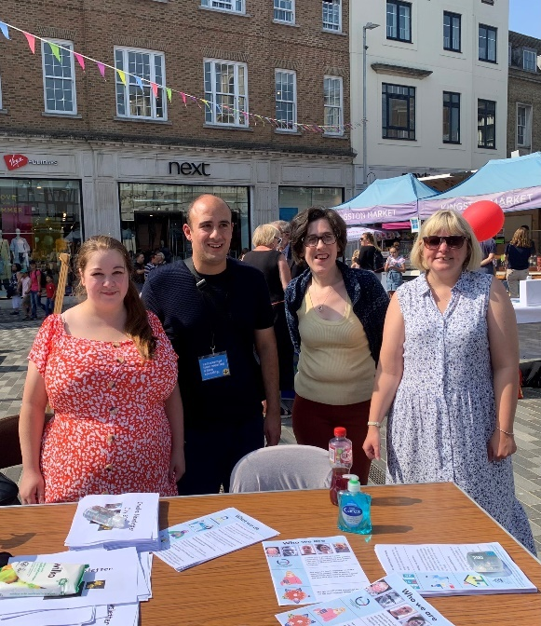
A highlight of this year was the disability awareness event, held in Kingston Market place in September, coordinated by Kingston Council.
This was the first time since 2019, that organisations were able to come together. Visitors to the Market Square were able to explore a number of stalls from local disability groups, including Kingston Mencap, Eco-Op, Kingston Centre for Independent Living, Kingston Association for the Blind, alongside other local disability organisations and groups.
It was wonderful to see many Councillors and Kingston Council staff in attendance, and the event gained lots of attention from members of the public.
Healthwatch Kingston joined a stall with Kingston Council’s Involve Team, who assist with chairing the All Age Learning Disability Partnership Board. We promoted the Partnership Board and our wider work.
The All Age Learning Disability Partnership Board looked at the work being undertaken by stakeholders to refresh the Kingston Carers’ Strategy. Healthwatch Kingston asked Partnership Board partners to give feedback on this work stream and provided our own findings from our work in this area.
At the December meeting we had and insightful presentations from students at Bedelsford and Orchard Hill. They showed us videos of how the physical environment of Kingston can prevent them from accessing services and businesses in Kingston and how this makes them feel.
Working with VCSEs:
We have continued to build strong relationship with voluntarily sector groups, such as Eco-Op, Mencap, and KCIL. The assist us with gathering user experiences and informing our reporting.

Your Care, Your Way – Working with Healthwatch England to gather views on health information and communication:
Healthwatch Kingston have joined the Healthwatch England “Your Care, Your Way” campaign.
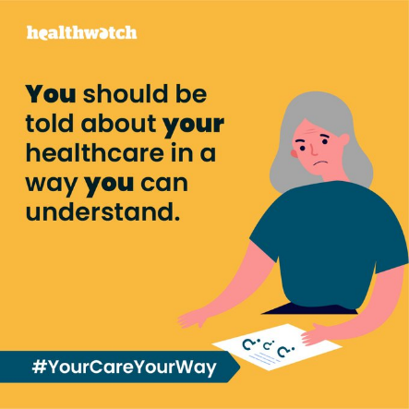
Clear, understandable information is important to help people make the right health and care decisions.
The Accessible Information Standard gives disabled people and people with a sensory loss the legal right to get health and social care information they can understand and communications support if they need it. Healthwatch England are asking if the standard being delivered by services, and does it go far enough?

The campaign ‘Your Care, Your Way’ aims to:
- Find out how well health and care services are delivering the accessible information standard.
- Make sure that, if the standard covers you, you know your rights.
- Find out who else has problems understanding information about their healthcare and needs to be covered by the standard.
Healthwatch Kingston, are reaching out to people with sensory impairments and learning disabilities, and other barriers to communication, to find out more about how the Accessible Information Standard is working for them, and what needs to change.

