July 2018
Student placement work experience daily activity report
I have managed to obtain work experience at Healthwatch in Kingston, and have gained an insight to the vital work that is being done here. Healthwatch is an organisation which operates on several different projects in order to better the standard of hospital services, and aid those who suffer with mental health, along with working on community care. They act as a ‘voice for the people.’ An example of a project that is being run is the Discharge project, which involves reviewing the experiences of patients after their stay at Kingston Hospital, with a focus on what the discharge process was like for them. They will compile an analysis and report of their findings, with recommendations which will be passed onto the hospital. A further example of a potential project they are planning, is based on social prescribing, which is a more holistic approach to helping patients. Rather than relying on purely medication, this outlook would refer individuals to particular social groups to improve their condition. This shows the support that Healthwatch is providing to those who need it, and the active position they take in giving this help.

Day 1:
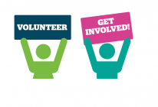
On the first day of the work experience process, I was lucky enough to attend a mental health trust meeting, where many Healthwatch representatives gathered together to discuss their projects and several issues that they were facing. This meeting gave me an appreciation of the hard work being done within the organization, and the challenges that we face as a nation. One key aspect of the meeting that I found interesting was the employment support funding plan, which asked the question, ‘How can we support sufferers of mental health issues in finding and maintaining employment?’ One solution to this issue is through the implementation of individual placement support workers (IPS). These individuals support sufferers of mental health throughout their employment, which allows people to get targeted support, which in turn, has a positive outcome in terms of maintaining employment. An example of what the support entails, includes helping previous sufferers write their CV, or more specifically, it could involve a support worker joining the individual in making certain adjustments to the work environment through discussions with the employer. This specific work has a positive outcome in terms of aiding people who struggle to gain and sustain a career, and has shown me that as well as addressing the issues at hand, Healthwatch and other similar organizations, are finding solutions to the problems, which is very inspiring to see.
There was a large focus on children and teenagers throughout the meeting, which I was excited to see, because as a young person, I am aware of many of the issues that we face in modern society today. It was stated that there was very little help for young people with mental health issues today, and that because of the fact that many teens are reluctant to speak out due to fear of parents or their school finding out, it is proving difficult to find a solution. The meeting discussed that early intervention prevention will be their main objective moving forward, which means aiming to provide young people with the help they need at an early age, so that the issue doesn’t continue or get worse.
Even through the first day of work experience, I have gained an understanding of the important work being done at Healthwatch, and how their actions and projects as an organisation are helping individuals today.

Day 2
On the second day of working with Healthwatch, I attended a session that was run by the charity, Dyscover. This is an organisation that works with people who struggle with aphasia- aphasia is a communication disability that is caused by damage to the brain, most commonly through a stroke. It can affect the ability to speak, read, write and understand what is being said. I was able to attend a session in which several volunteers spoke to those who suffered with aphasia, and simply by including each individual within the group, it allowed others to feel more confident sharing their own ideas and opinions. Furthermore, through observing the workers, I was able to see the different techniques used in order to help the members of the group interact and understand certain words or phrases slightly better. One of these approaches was through writing down the words and displaying them to the group, and another was simply speaking loudly and clearly, ensuring every individual could hear them. Aphasia is a very isolating condition, and through having this first-hand experience with these patients, it put some of my previous knowledge into practise and allowed me to fully observe the enduring consequences of a stroke. It also showed me how important the work being done by Dyscover truly is, and revealed the value of offering long-term support to sufferers of aphasia, as it means that members can make improvements in the ability to communicate, which in turn, increases their self-esteem.
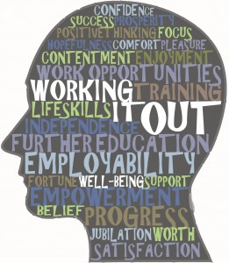
Day 3
I started off the third day in Healthwatch Kingston by simply reading into some of the previous work that this organisation has done in relation to research on young people. They highlighted many of the issues that young people face, such as bullying and the harmful effects of social media. It was also picked up on the fact that individuals who identified as something other than straight, rated their emotional wellbeing lower overall. Through identifying these factors, it showed me that there is a positive approach being taken towards young sufferers of mental health, and Healthwatch are truly acting as a voice for those who are struggling. I found that the employees of this organization were very inclusive and took on board my ideas, which personally I appreciated as it meant I felt more involved in the work that was taking place.
In the afternoon, I attended a Rise Café information and advice session. Rise is a social enterprise that’s main aim is to get rid of social injustice, and organise events in which people from all across the social hierarchy can interact and bond. The Rise café event in particular, involves several individuals eating food, playing scrabble and watching films, and is open to all community members. It allows people to bond with others, whom they may not have previously spoken to- it gives individuals a place where they feel they belong. Every month, Healthwatch organizes a speaker to come in and talk to the group, helping them with certain aspects of their daily life. When I attended the session, a member of the Kingston Advocacy group (KAG) was visiting the café. KAG provides advocacy and aids those who have trouble with benefits and other financial issues. I was able to see the help that she was providing, by assisting some of these members in handling financial forms and different problems they each had. I was also able to observe the great work that Rise is doing as a charity, and the work that Healthwatch does to contribute to this positive outcome.

Day 4
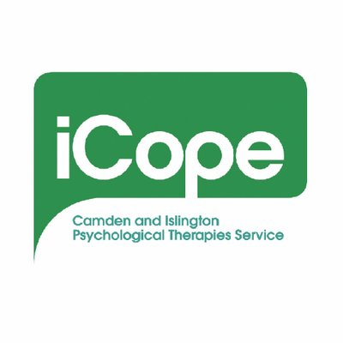
On my fourth day of work experience, I attended an iCope review meeting. This is a free service that offers different types of therapies to help people find ways to cope with their daily issues. It offers a range of treatments for anxiety and depression, through the use of a range of differentiating courses and individual treatments. Despite not having a previous knowledge of the project that Healthwatch was doing with iCope, I was able to generally understand the basis of what the meeting was about. It was great to observe the interactions between the two organisations, and it was also good to see iCope’s eager take on the issue at hand; they clearly were excited to receive feedback on their service for the public’s perspective.
I also briefly popped into a support group session run by Fastminds, an operation that works with those who suffer from ADHD. From the brief interaction I had with the members of the group, I was able to see how discussing their condition was such a massive help, and an effective form of therapy. All of the individuals were very self-aware of their diagnosis, and rather than dwelling on the negative aspects, they embrace the fact that it is part of who they are, and not to be looked upon in a negative way. I think it was inspiring to see these people working together, and through the planning of a neurodiversity arts festival, they are spreading their encouraging message. By simply talking and doing different activities, such as painting and crafts, they were communicating in an effective way, which they may not get the chance to at home.
Day 5
On my final day, I was going to attend an event run by Staywell, which is a specialist confidential, and free information and advice service for people over 60 years of age. It organises several social activities, such as the Raleigh House, which is a centre for those over 65 years old. From personal experience, I know this environment is a brilliant way for these elderly people to make friends and socialize with others. Healthwatch is helping to fund the event that Staywell were running, and reinforced to me the positive approach this service takes in regard to spreading these beneficial messages.
Overall, my time working for Healthwatch has been so helpful, and I have gained an insight into the working world. Through seeing the important work that they are doing, it has really shown me that I would love to get involved in a career that’s just as proactive and involved as Healthwatch is. I am very appreciative to have been given the chance to have had this brilliant opportunity.
Thank you!

