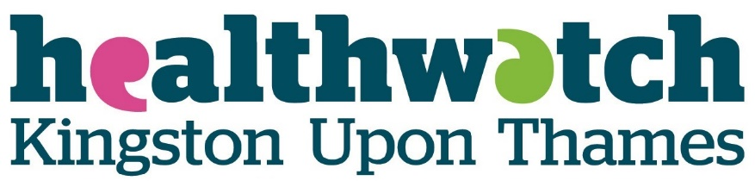
http://www.healthwatchkingston.org.uk/

Work Experience (Student 1)
Monday 15th July-Friday 19th July
Weekly Report
As organised by the school, we were required to take part in work experience for the week beginning Monday 15th July. I chose Healthwatch Kingston as I am interested in going down the path of psychology, and have a great interest in mental health. I was accompanied by a fellow student during this week.

Monday 15th July
On the first day as expected I was quite nervous to be in a very new and different environment, however I was instantly relaxed by the very warm welcome from the Chief Officer Stephen. He gave us an excellent tour of the building and answered any questions we had. He gave us a lot of resources for the week, including a very detailed and well-structured plan of the week, including a complete explanation with all the timings of the day, this was very helpful as it gave me an idea of the activities I would be taking part in all through the week. We started off by receiving a very comprehensive description of what Healthwatch Kingston does, what it has achieved, and what plans are for the future. This gave me a very good understanding of the organisation and interested me in their work such as Youth Out Loud! which is a group of young people who aim to improve the local health and care services of young people in Kingston. To give us an even more thorough understanding of the company, we were given the annual reports for 2018/19 and 2017/18, this showed us the progress Healthwatch Kingston has made over the years, and how it has grown. The task given to us was straightforward but I found it helpful and interesting. We were asked to evaluate the annual reports, and feedback about the strengths and weaknesses of them. It was quite pleasant to have our ideas listened to and appreciated as it felt like we were helping Healthwatch in the same way they were helping us. Similarly, after lunch, after going through the application for a Time To Change Hub Coordinator, we were asked to come up with three questions to ask candidates in an interview. They explained that they wanted questions from young people so that our voices could be heard, again this made us feel appreciated.
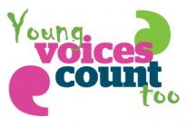

Tuesday 16th July
On this day it was being led by Scott, the Projects and Outreach Officer. He gave us a good explanation of community event planning, as well as a very helpful explanation of event planning for people with learning disabilities, I found this useful as I learnt all the things you need to consider, for example, if the venue arranged suits the needs of the people attending, if they have a ramp for wheelchair users etc. The activity given to us next was very useful and eye opening as we were asked to construct an evaluation survey for an event that was in either Easy Read or plain English, I found this beneficial as it gave me an idea of the everyday tasks that people with learning disabilities struggle with, and how we can make people’s lives easier. After lunch I was asked to design a poster advertising the All Age Learning Disability Partnership Board. I found it engaging learning about the projects of Healthwatch Kingston and how they’re helping people who are less able. The next task given was to create a poster advertising the All Age Learning Disability Partnership Board, this was an easy and enjoyable task.

Wednesday 17th July
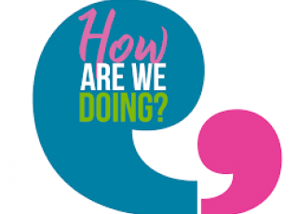
On this day I attended my brother’s graduation ceremony at Portsmouth University so I did not go to Healthwatch.

Thursday 18th July
This day was led by Jaimy, the Communications and Engagement Officer. The morning was spent going through the criteria for a communications plan in great detail, I received a very elaborate explanation of the objectives, strategies and plans for Healthwatch Kingston. My understanding of a communications plan increased when we were asked to construct our own plan for organising an event and we were able to express our own ideas about how Healthwatch can promote itself even more, I enjoyed this task as we were encouraged to be as creative as possible. After lunch we were asked to create more posters and social media posts to promote Healthwatch’s campaigns such as Youth Out Loud! Again, we were able to express our ideas of how they can promote themselves.
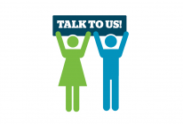

Friday 19th July
Today was the last day at Healthwatch Kingston. We were asked to write up our weekly report and our experiences of being here. Overall, I found this week to be very interesting, exciting and a useful experience for me. I thought it was a fantastic idea for a different person to lead the activities each day, as it gave us a taster of what each person’s role is here. It was a very pleasant simulation of what the real world of work is like and I’m very grateful for the time and effort the team at Healthwatch put into planning our week for us, and for the great week of activities they arranged. I think Healthwatch Kingston is a lovely place to work, with a very happy and relaxed environment, a clean and excellent building, and a very kind and entertaining team. I have very much enjoyed my experience here.

“I think Healthwatch Kingston is a lovely place to work, with a very happy and relaxed environment, a clean and excellent building, and a very compassionate and hardworking team. I have very much enjoyed my experience here”
Because of GDPR, I was asked if I would be happy to provide my consent for the above quote to be used by Healthwatch Kingston: I am happy for Healthwatch Kingston to use this quote for the website or annual report.

http://www.healthwatchkingston.org.uk/
Work Experience (Student 2)
Monday 15th July-Friday 19th July
Work Experience Report
Who I am
I am a student from Holy Cross Girls Secondary School and for my work experience from the period 15th July until 19th July, I was placed at Healthwatch Kingston upon Thames. Healthwatch England is an “umbrella organisation”, as mentioned by the Chief Officer Stephen Bitti, as they have local Healthwatch branches in each local authority in England. They are an organisation that supports vulnerable individuals and assist them in their health or social care needs. They advise people on the different services available to them which are suitable for their individual situations.
I worked Monday-Friday, 9:30am-4:30pm but the Chief Officer of the organisation sometimes let us leave earlier due to us finishing our tasks earlier. Before arriving at my placement, I was a little bit nervous as I am not familiar with the working environment and I wasn’t sure if I would settle in as I quickly as I did or whether I would adjust well to the setting of the placement. I was also unaware of what kind of an organisation Healthwatch is, therefore I was unaware of their expectations and what types of tasks they would give me to do.
My experiences this week
My week started off with me arriving at Healthwatch Kingston on Monday and I was introduced to (as mentioned before) to the Chief Officer of the organisation, Stephen Bitti, who began the day by giving us a tour of the building and an introduction to what Healthwatch is and what it is they do. After settling in, we were given a task to complete; evaluating and reviewing their Annual Report 2018/2019. Doing this exercise gave me more of an insight to what Healthwatch does in more depth and the differences they’ve made in people’s lives. Doing this task allowed me to gain skills and more knowledge on how to achieve a good evaluation and the different aspects you have to consider when evaluating a report. After completing this task, we were asked to create 3 questions to ask the TTC Hub Coordinator candidate at the final interviews.
How I felt
It was very refreshing knowing that an important organisation was willing to hear the opinions of two 17-year olds and are looking for in a person who could improve society and benefit young people and interested in what we are expecting of the community. Completing this task allowed me to think about the different things that young people feel are important and what changes could be made to improve the community.
On Tuesday, we were introduced to another member of the team, Scott, who was our lead for the day. He introduced us to Easy Read and Plain English, which is the use of simple English, making everything clearer for people with and without learning disabilities to understand. We were given the task of making an Easy Read questionnaire that we would give to people and doing this was a new experience and skill I gained because I could think about the different questions I could ask and the wordings of my questions.
What I learnt today
Learning about the different ways to make things clearer for people who have learning disabilities, such as including pictures and colours in posters or putting texts in Plain English to help them understand the information made me realise the different ways to approach someone with learning disabilities and the different ways of communicating with them. After learning about that, we were given the task of creating a poster for Wednesday’s event, All Age Learning Disability Partnership Board Community Event, using all the ideas we were given and taught during Tuesday’s morning session. After completing that task, we had to think about the different things and aspects that are included in an event such as the venue, costs, catering and so on. Doing this made me realise how much effort and time it takes to make an event happen and the amount of factors that need to be considered, giving me the opportunity to gain management skills.
On Wednesday, I accompanied the team to their All Age Learning Disability Partnership Board Community Event which was an interesting experience that I enjoyed. It was very new seeing the effort that goes into making an event happen and the different types of information that is shared during events such as this one. I was surprised to see the different organisations that are involved with Healthwatch and the different partnerships they have.
What I learnt today
I learnt about the different changes that each organisation is willing to do and the methods they are going to be using to bring about those changes. One of which was the use of Makaton in hospitals, which I though was a very good idea because it’s beneficial for an individual to know the different ways to communicate with people especially those who have learning disabilities and I feel that it’s important for doctors and hospital staff to know about Makaton just in case they are to come across someone with a learning difficulty to eliminate any communication barriers.
On Thursday, we were introduced to Jaimy who is the Communications and Engagement Officer of Healthwatch, who ran a communications workshop with us. During this workshop we learnt about the different factors to consider when thinking of ways to communicate with others. We had to think about the objective of our communication plan, the audience, different strategies and communication channels we could use to get our message across, when we are to launch our communication plan and the key message. We also discussed how we would evaluate our campaign and the methods we would use to see whether the campaign was a success or not.

Applying what I learnt
After the communications workshop, we had to apply our knowledge that we learnt and come up with different ideas for Healthwatch to use to approach young people and inform them about what they do and the different activities they could get involved with. After doing that, we were asked to create a poster for Youth Out Loud! and how we would communicate to the young people in the Kingston Community and make them more aware of Youth Out Loud!.
On Friday, we had to view the different ways we could write up our report and how we would structure it. For the remainder of the day we had to write up our report of the whole week, including our experiences, what we learnt and how we felt about the whole week.
In conclusion, I would say this week has been a very important week in my life as it has taught me a lot of skills and how much effort is put into an organisation such as Healthwatch. I am going to be leaving this week with time management skills, communication skills, event planning skills and many more. I am very grateful to have had this opportunity and have enjoyed my time here. At the end of each day we had to write up a report of our experiences of our day and that helped me to be more organised. I am very grateful for Healthwatch team as they made me feel welcome and made sure that I felt comfortable; it was a lovely working environment to be in. I don’t think the week would’ve been the same without them or the support they gave us.
“I am very grateful to the Healthwatch Kingston team as they made me feel welcome and made sure that I felt comfortable and it was a lovely working environment to be in.”
Because of GDPR, I was asked if I would be happy to provide my consent for the above quote to be used by Healthwatch Kingston:
I am happy for the Healthwatch team to use this quote in their annual report.

